Exp.No-10

10. Perform moving of an image from one place to another.

Aim:
To translate (shift) an image using OpenCV.

Procedure:
- Start the program.
- Import OpenCV and NumPy.
- Read the input image.
- Create a translation matrix.
- Apply the translation to the image.
- Display the original and translated images.
- Save the translated image.
- Stop the program.
Program:
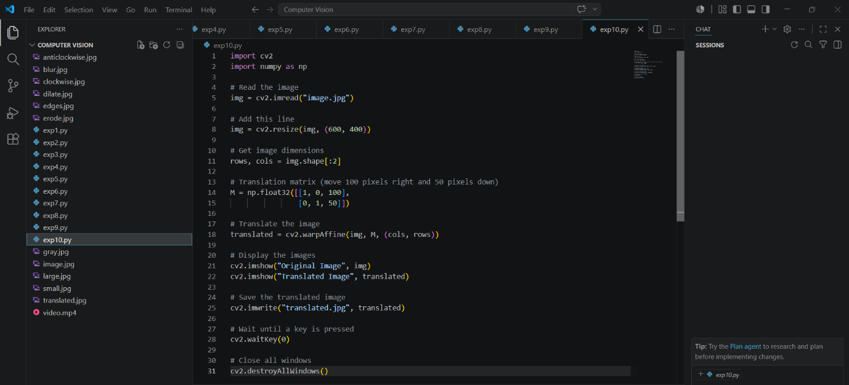

Input:


Output:
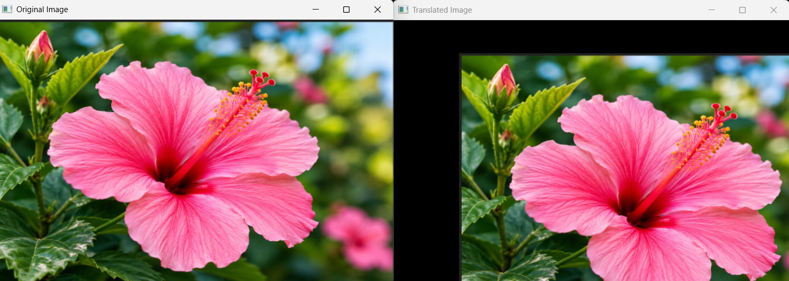
Result:
The input image was successfully translated (shifted) horizontally and vertically using OpenCV.

